Step 1 👍

Just follow the steps and commands as is it apne powershell me copy karte jao …

Chal jayega REst API with POwershell

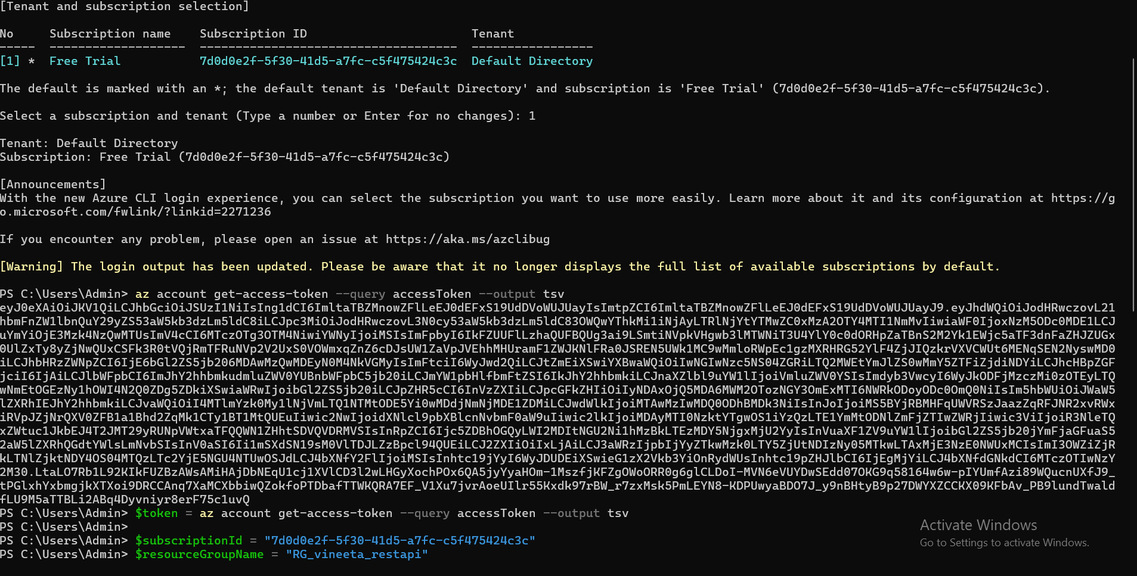

Humko token generate karke , values ko variables me store karna hai jisko hum ‘$” sign se denote kar rahe hai wo variables hai and usme hum value store kar rahe hai .

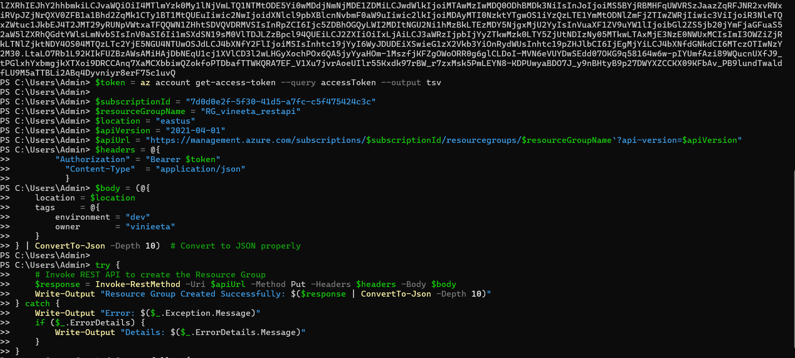

Ab yeh sabke baad when u hit enter , apko yeh output dikeha , which means your resource group from REST API is created.

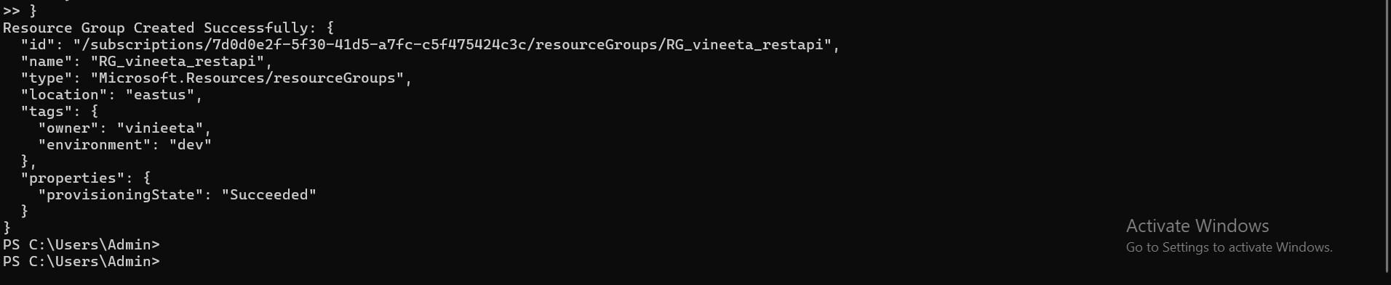

RESTAPI WITH POSTMAN 👍

1 ) postman install karlo you will gt this page

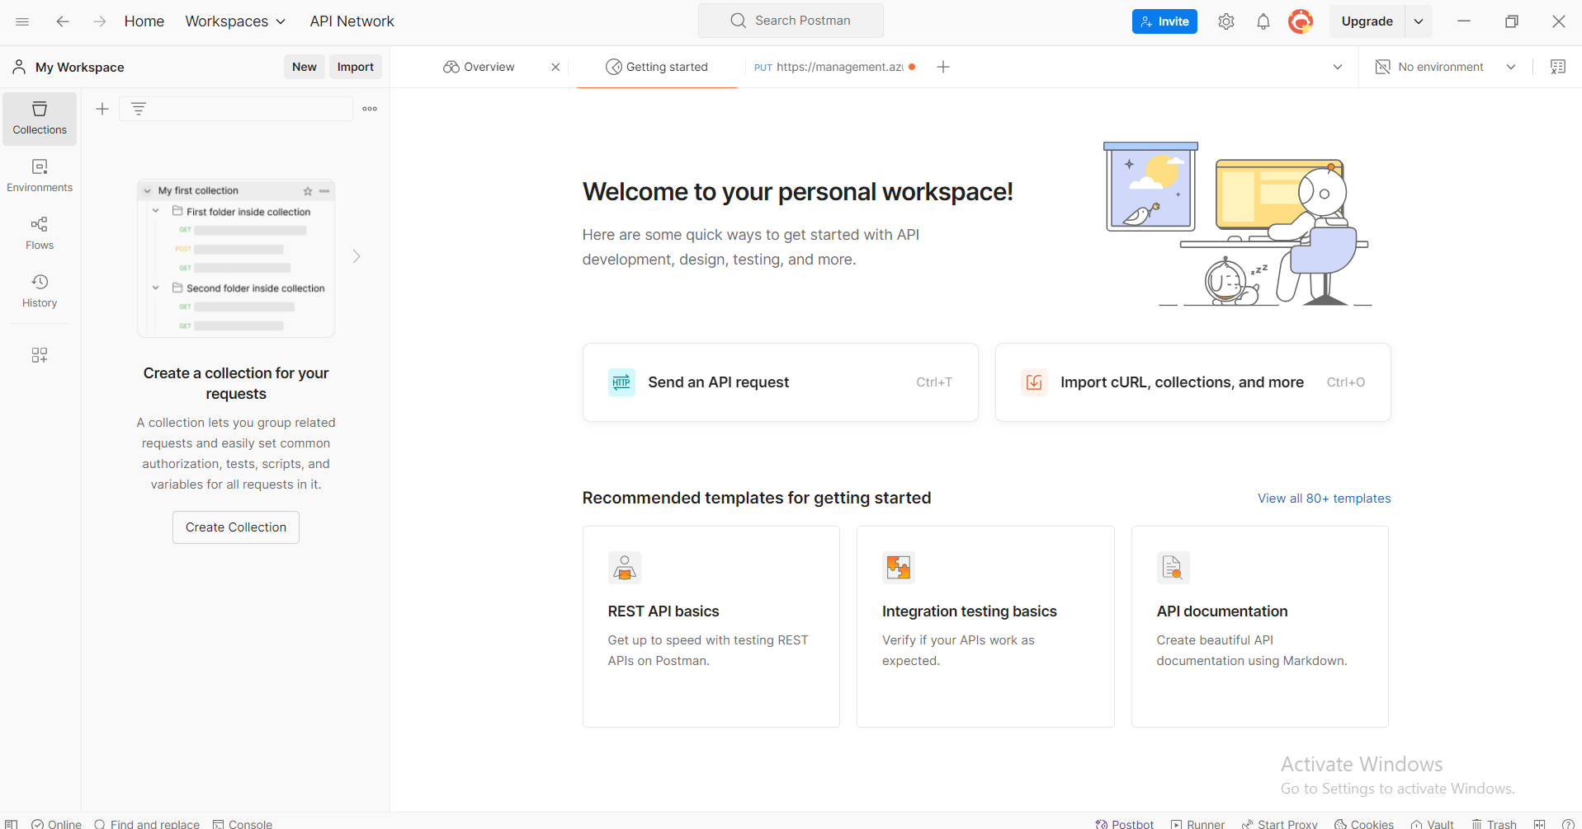

2) ab isme ek new tab open karo (wahan + jisa bana hai click karke) jahan url create karenge , bina url ke api nahi chalta ..

Ab isme pehle autorisation pe jaoo , bearer token select krlo , nahi kar pa screenshot dekho …dard mat lo 😛

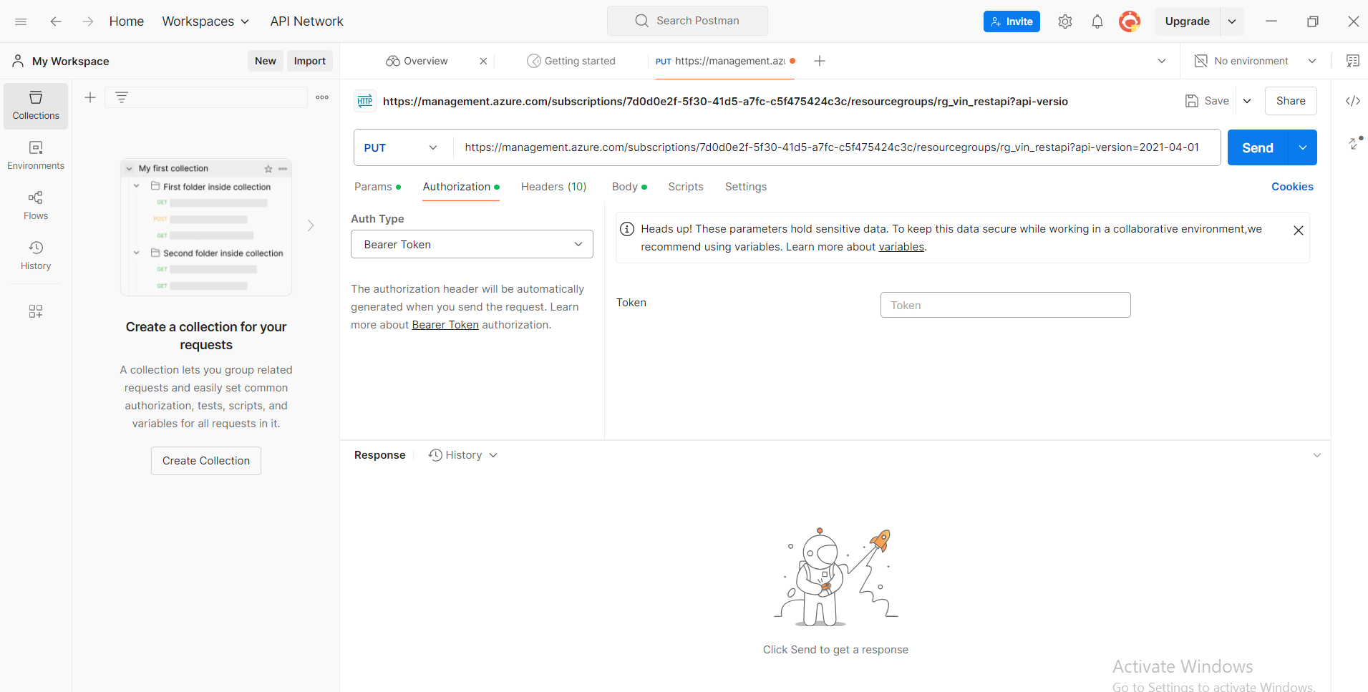

Ab hum headers tab me jayenge wahan , neeche dekho neeche ….are kahan dekh rah ho …neeche screenshot me dekho 😛

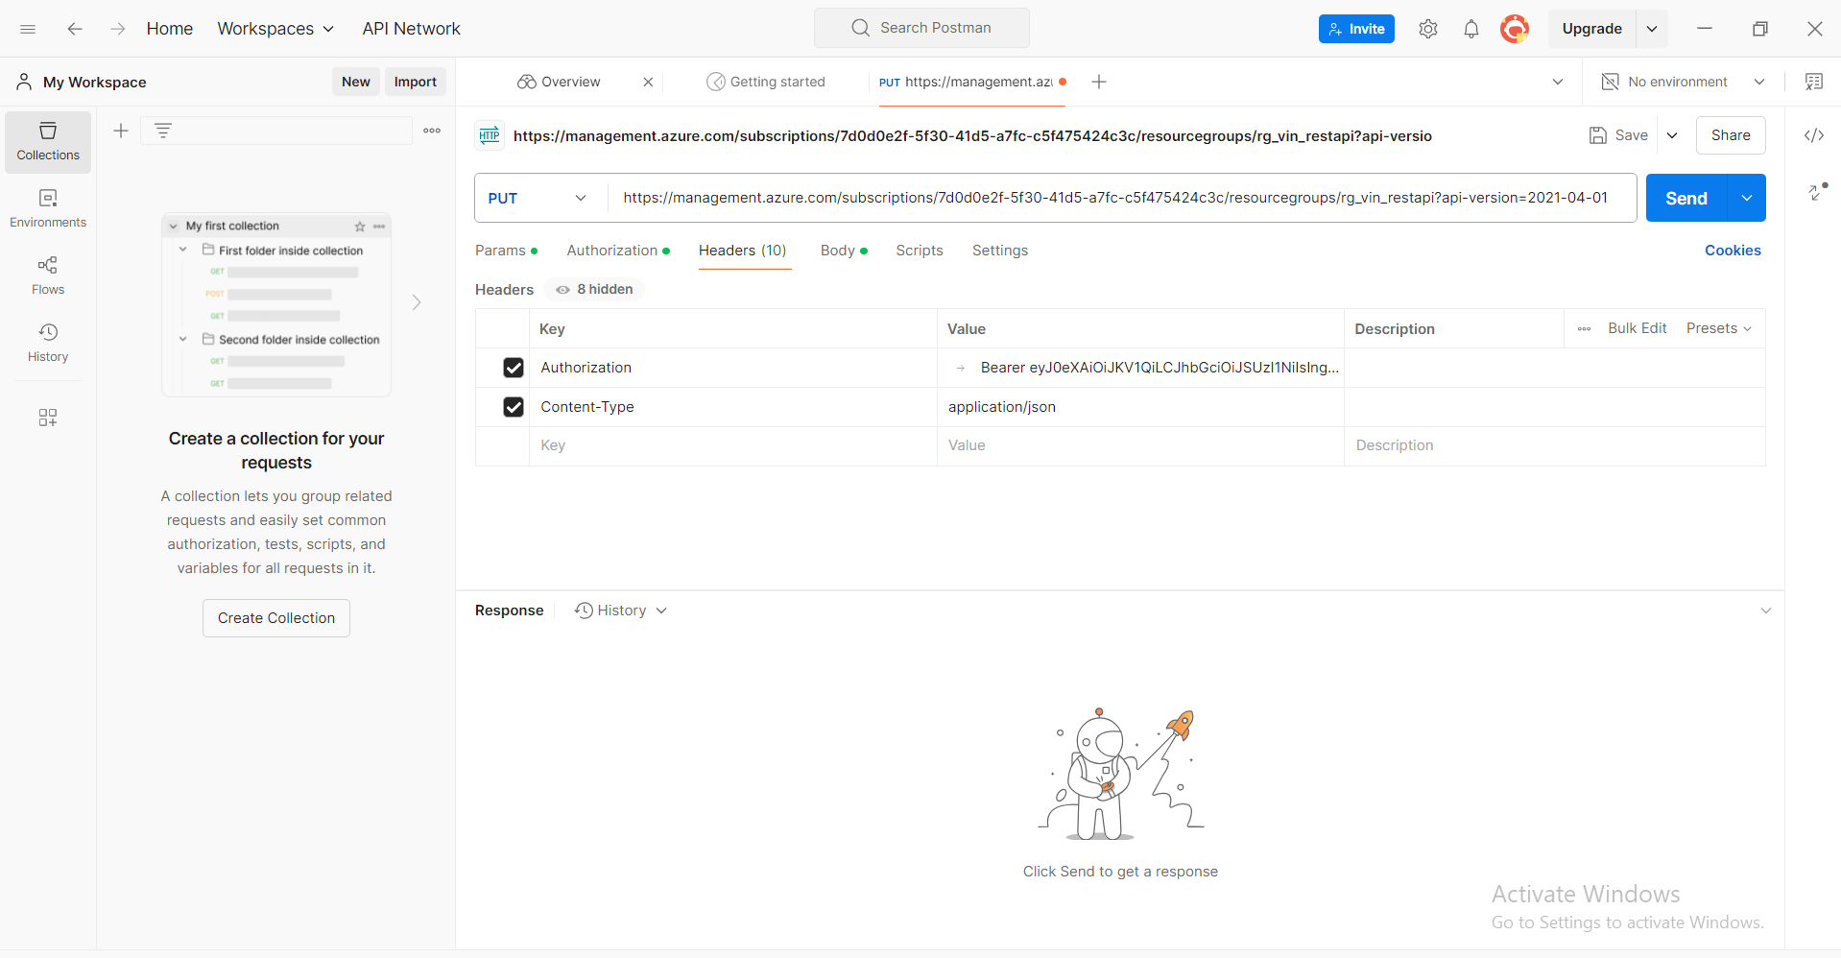

Isme authorization me , bearer<token> token value jo create ki thi wo yahan paste karo aur <> mat lagana saath me

Ab aate hai body tab pe , ab usme “raw” button choose karna , JSON format , isme yeh paste karo jo neeche screenshot me hai

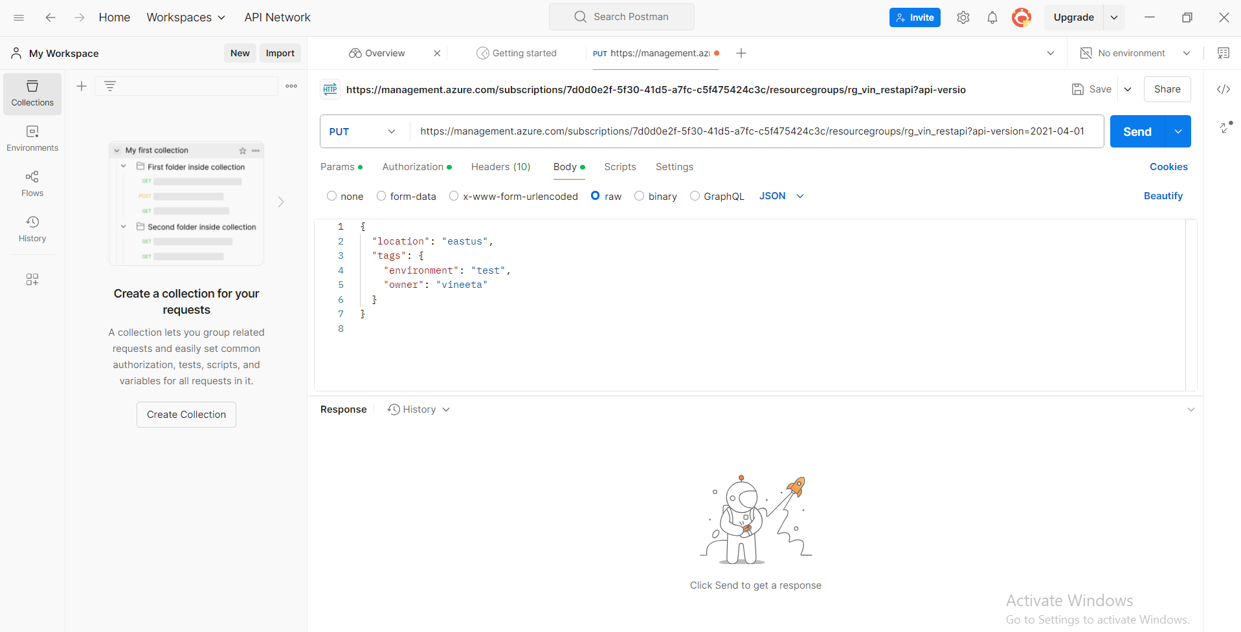

Owner and environment value edit kar lena , na karni ho to mera naam b rakh sakte ho .. 😛

Ab jahan URL paste karna hai wo esa hoga , PUT option select karo URL paste karo 🎉

Kuch esa dikehga URL

: <https://management.azure.com/subscriptions/7d0d0e2f-5f30-41d5-a7fc-c5f475424c3c/resourcegroups/rg_vin_restapi?api-version=2021-04-01>

Isme subscription id resource group yeh sab values khud ki rakha edit plzz…

ab yeh sab tam jhaam ke baad ab apne sab sahi follow kiya hai to , click send …

Jaise hi send karoge wahan output aayega kuch esa 👍

Ab url ki values edit karne ki jarurat nahi , powershell me jake yeh command chala lena ..khud hi de dega

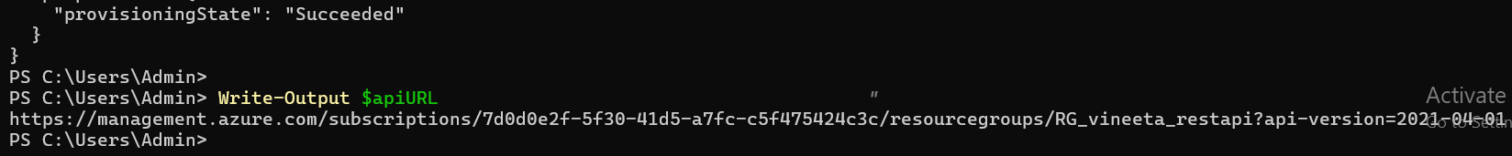

Ab is URL ko copy karo , postman me paste karo

Ab neeche dekho esa output ayega response me 👍

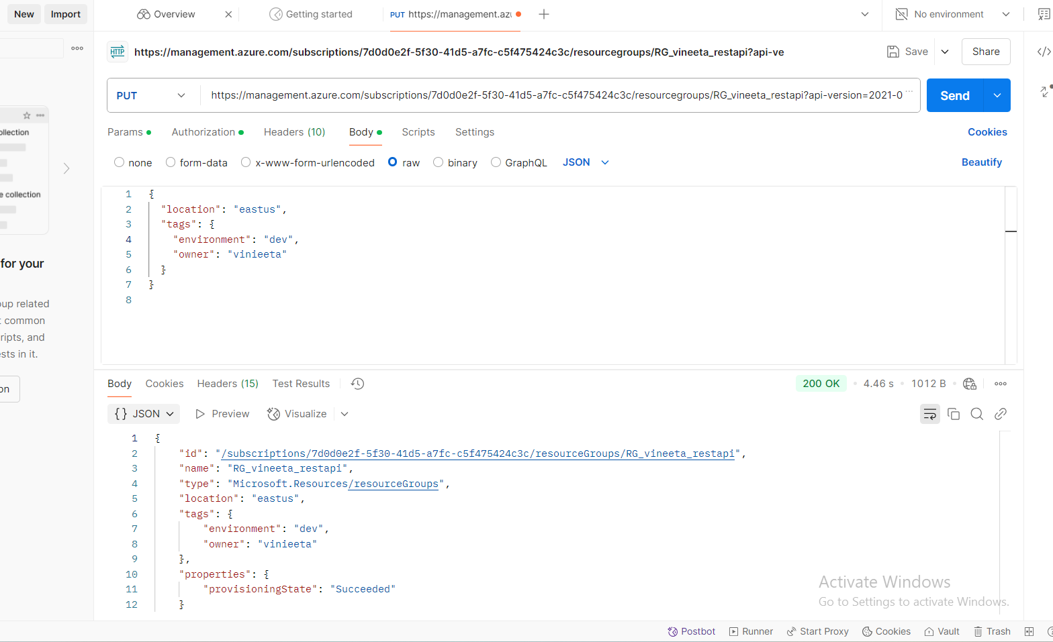

Thank me later , just kidding , vineeta . LOLZ 😂